ISQA 4900 Activity 2

Krishnakumari Yachamaneni

Published Website on GitHub Pages - <https://kyachamaneni.github.io/>

1. Created a web page with three tabs:
   1. Home
   2. Shuttle Routes
   3. UNO Campus Map
2. Home page



1. Shuttle Routes page

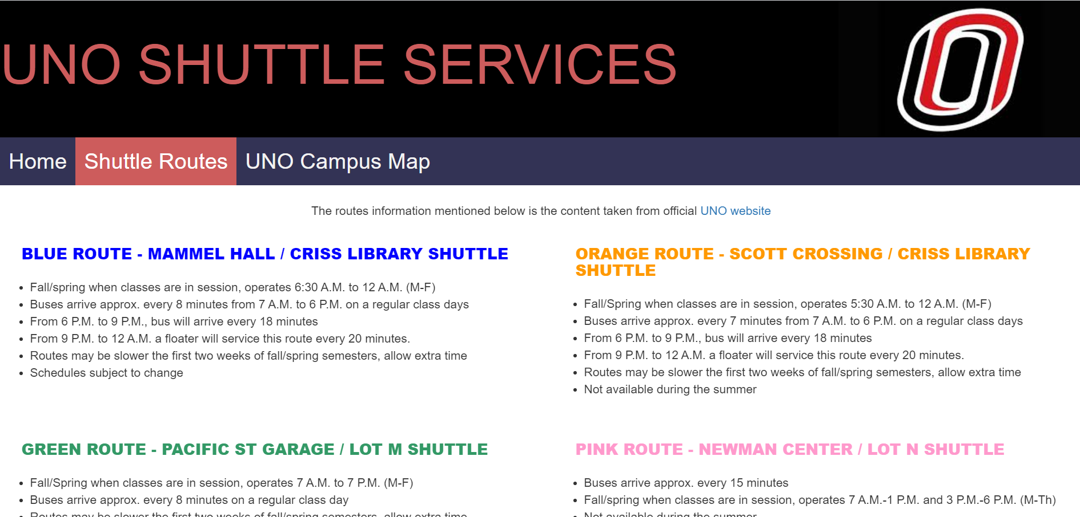

1. UNO Campus Map page

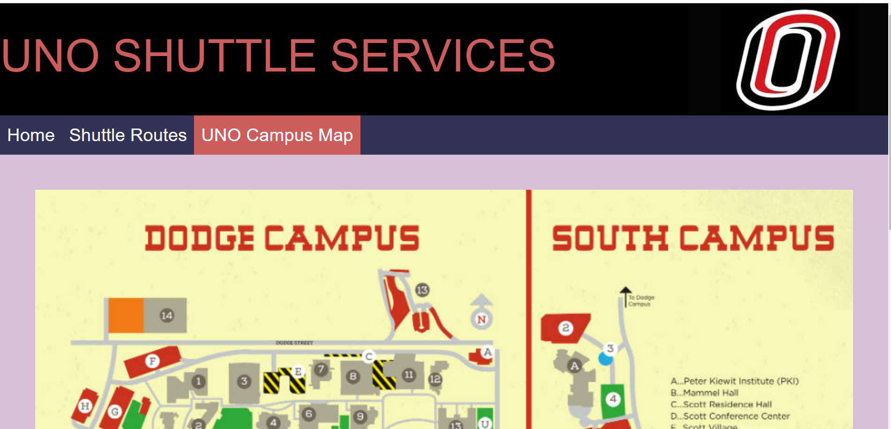

# Questions

1. **What is the value of having a CSS file for each html page? Why not simply embed the CSS in each web page?**

We can easily maintain the HTML pages if we maintain separate CSS file. The HTML page also looks clear to understand as the messy styling is maintained in the separate CSS page.

1. **There are many cloud-based shared document tools such as DropBox, Box, Microsoft OneDrive and GoogleDrive. What is an advantage of using a tool like Git (GitHub Desktop) and GitHub over simply using other cloud-based shared document tools to manage code**

The Github makes us to work on our local computer and easily push and pull the changes from the cloud. And also we can track the changes when multiple people work on the project.

We can also view the code of the open source projects and utilize that in our project.